OPOSSUM v0.5.0 released

The developers are happy to announce the release v0.5.0 of the optic design / simulation software OPOSSUM **(link auf Seite).** Over the past fourreleases many concepts and features haven been worked out. Meanwhile the software can already be used for simulating real-life optical models. However, since the software is still lacking a real user interface (it’s more like an optics library) and file / data formats are rapidly changing we would not yet recommend to actually use the software for real projects. Nevertheless, if you are willing to test the software (using Rust as programming language) feel free to do so. On the other hand, we would be happy and thankful for any feature request or bug report. All bugs / feature requests should be reported to our [software repository](https://git.gsi.de/phelix/rust/opossum/-/issues).

Here are the highlights of the v0.5.0 release.

# Introduction of a geometry model

This release mainly concentrated on the development of a concise geometry model which involves the implementation of a global coordinate system and the positioning of optical elements in 3D space using isometric transformations. Furthermore, we worked out a concept for positioning nodes in a way that simply “works as expected” within the typical optical design workflow.

In contrast to other well established design software solutions (e.g., ZEMAX or Code V) we wanted to avoid often confusing “coordinate breaks” as much possible. For this, we make use of the old concept of an optical axis. While an optical axis is, strictly spoken, not always concisely defined, it dramatically simplifies positioning and aligning optical elements. For the majority of optical systems, it is sufficient to simply define the distance between to optical elements and optionally a tilt or decenter. This allows for example to model the following optical setup which requires only two distances and two tilt angles:

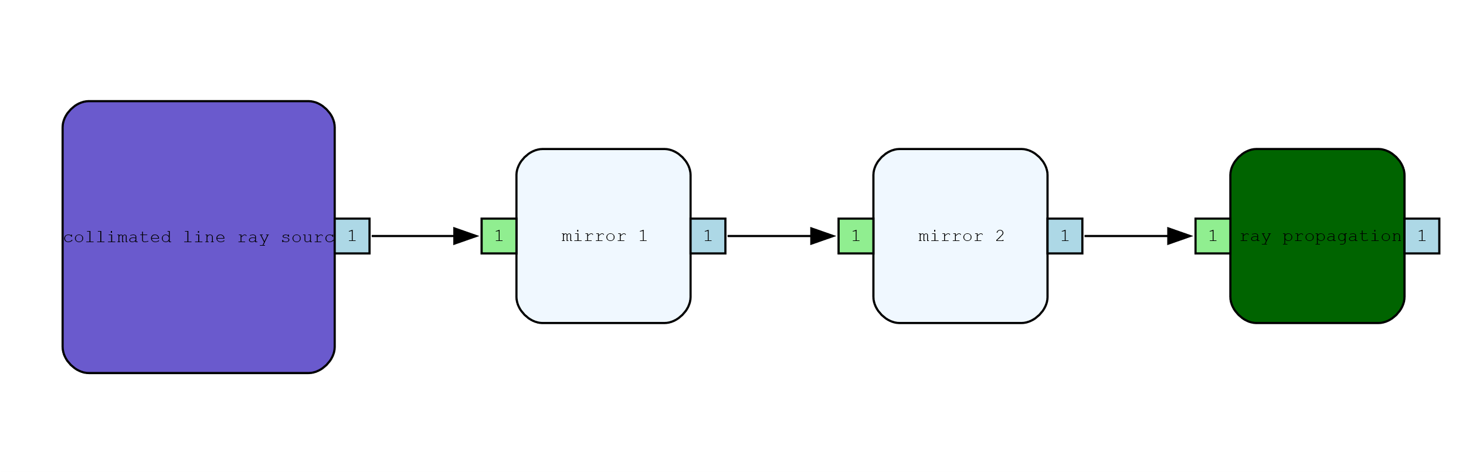

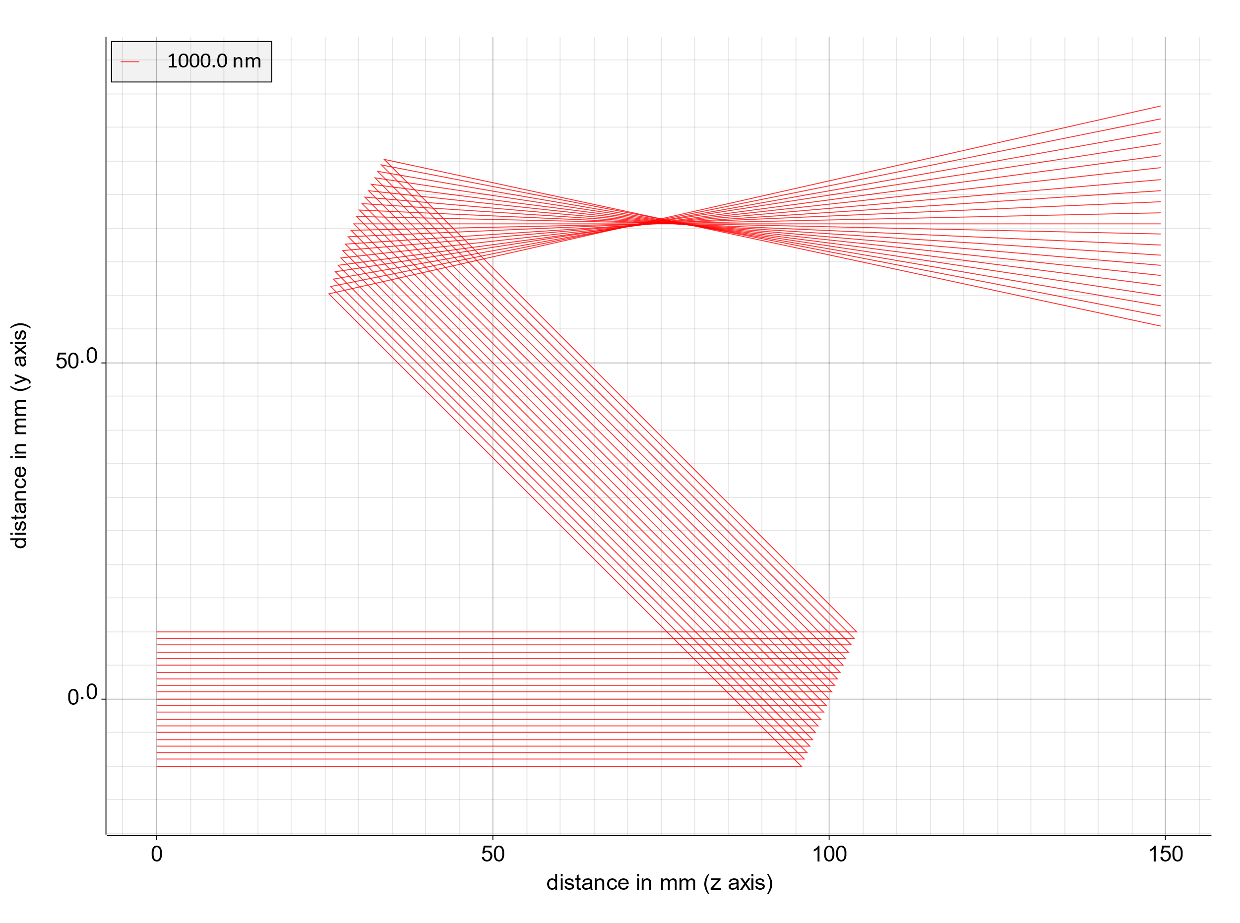

Above model so can be modelled with less than 10 lines of (Rust) code.

With the new geometry model and the usage of so-called “reference nodes” (a node referring to another existing node) it is also possible to model optical systems where beams can pass elements more than once.

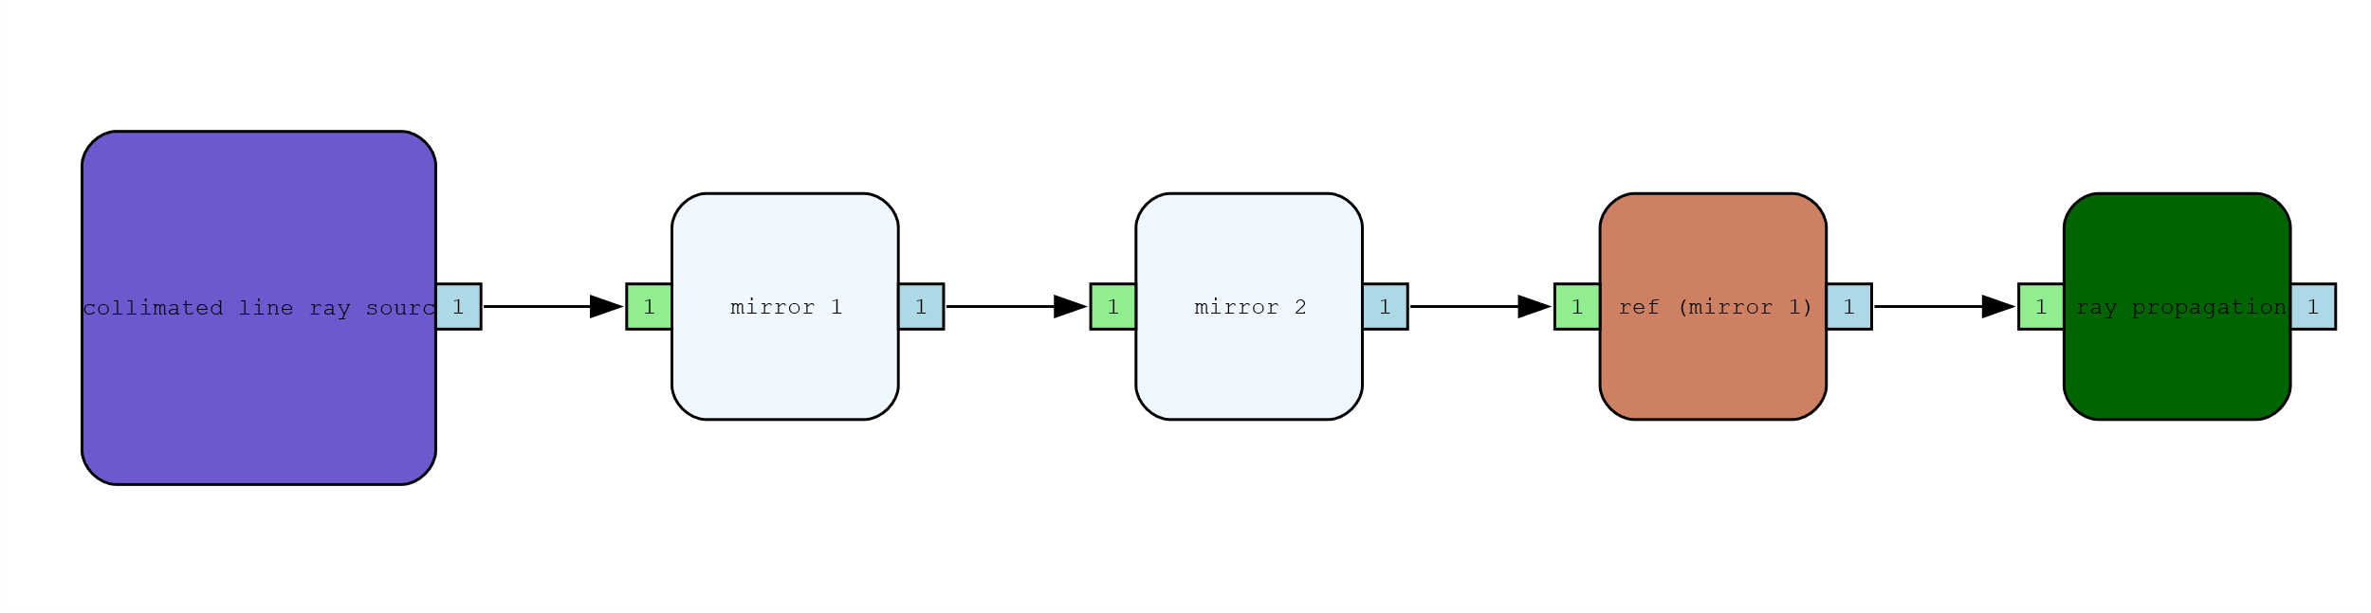

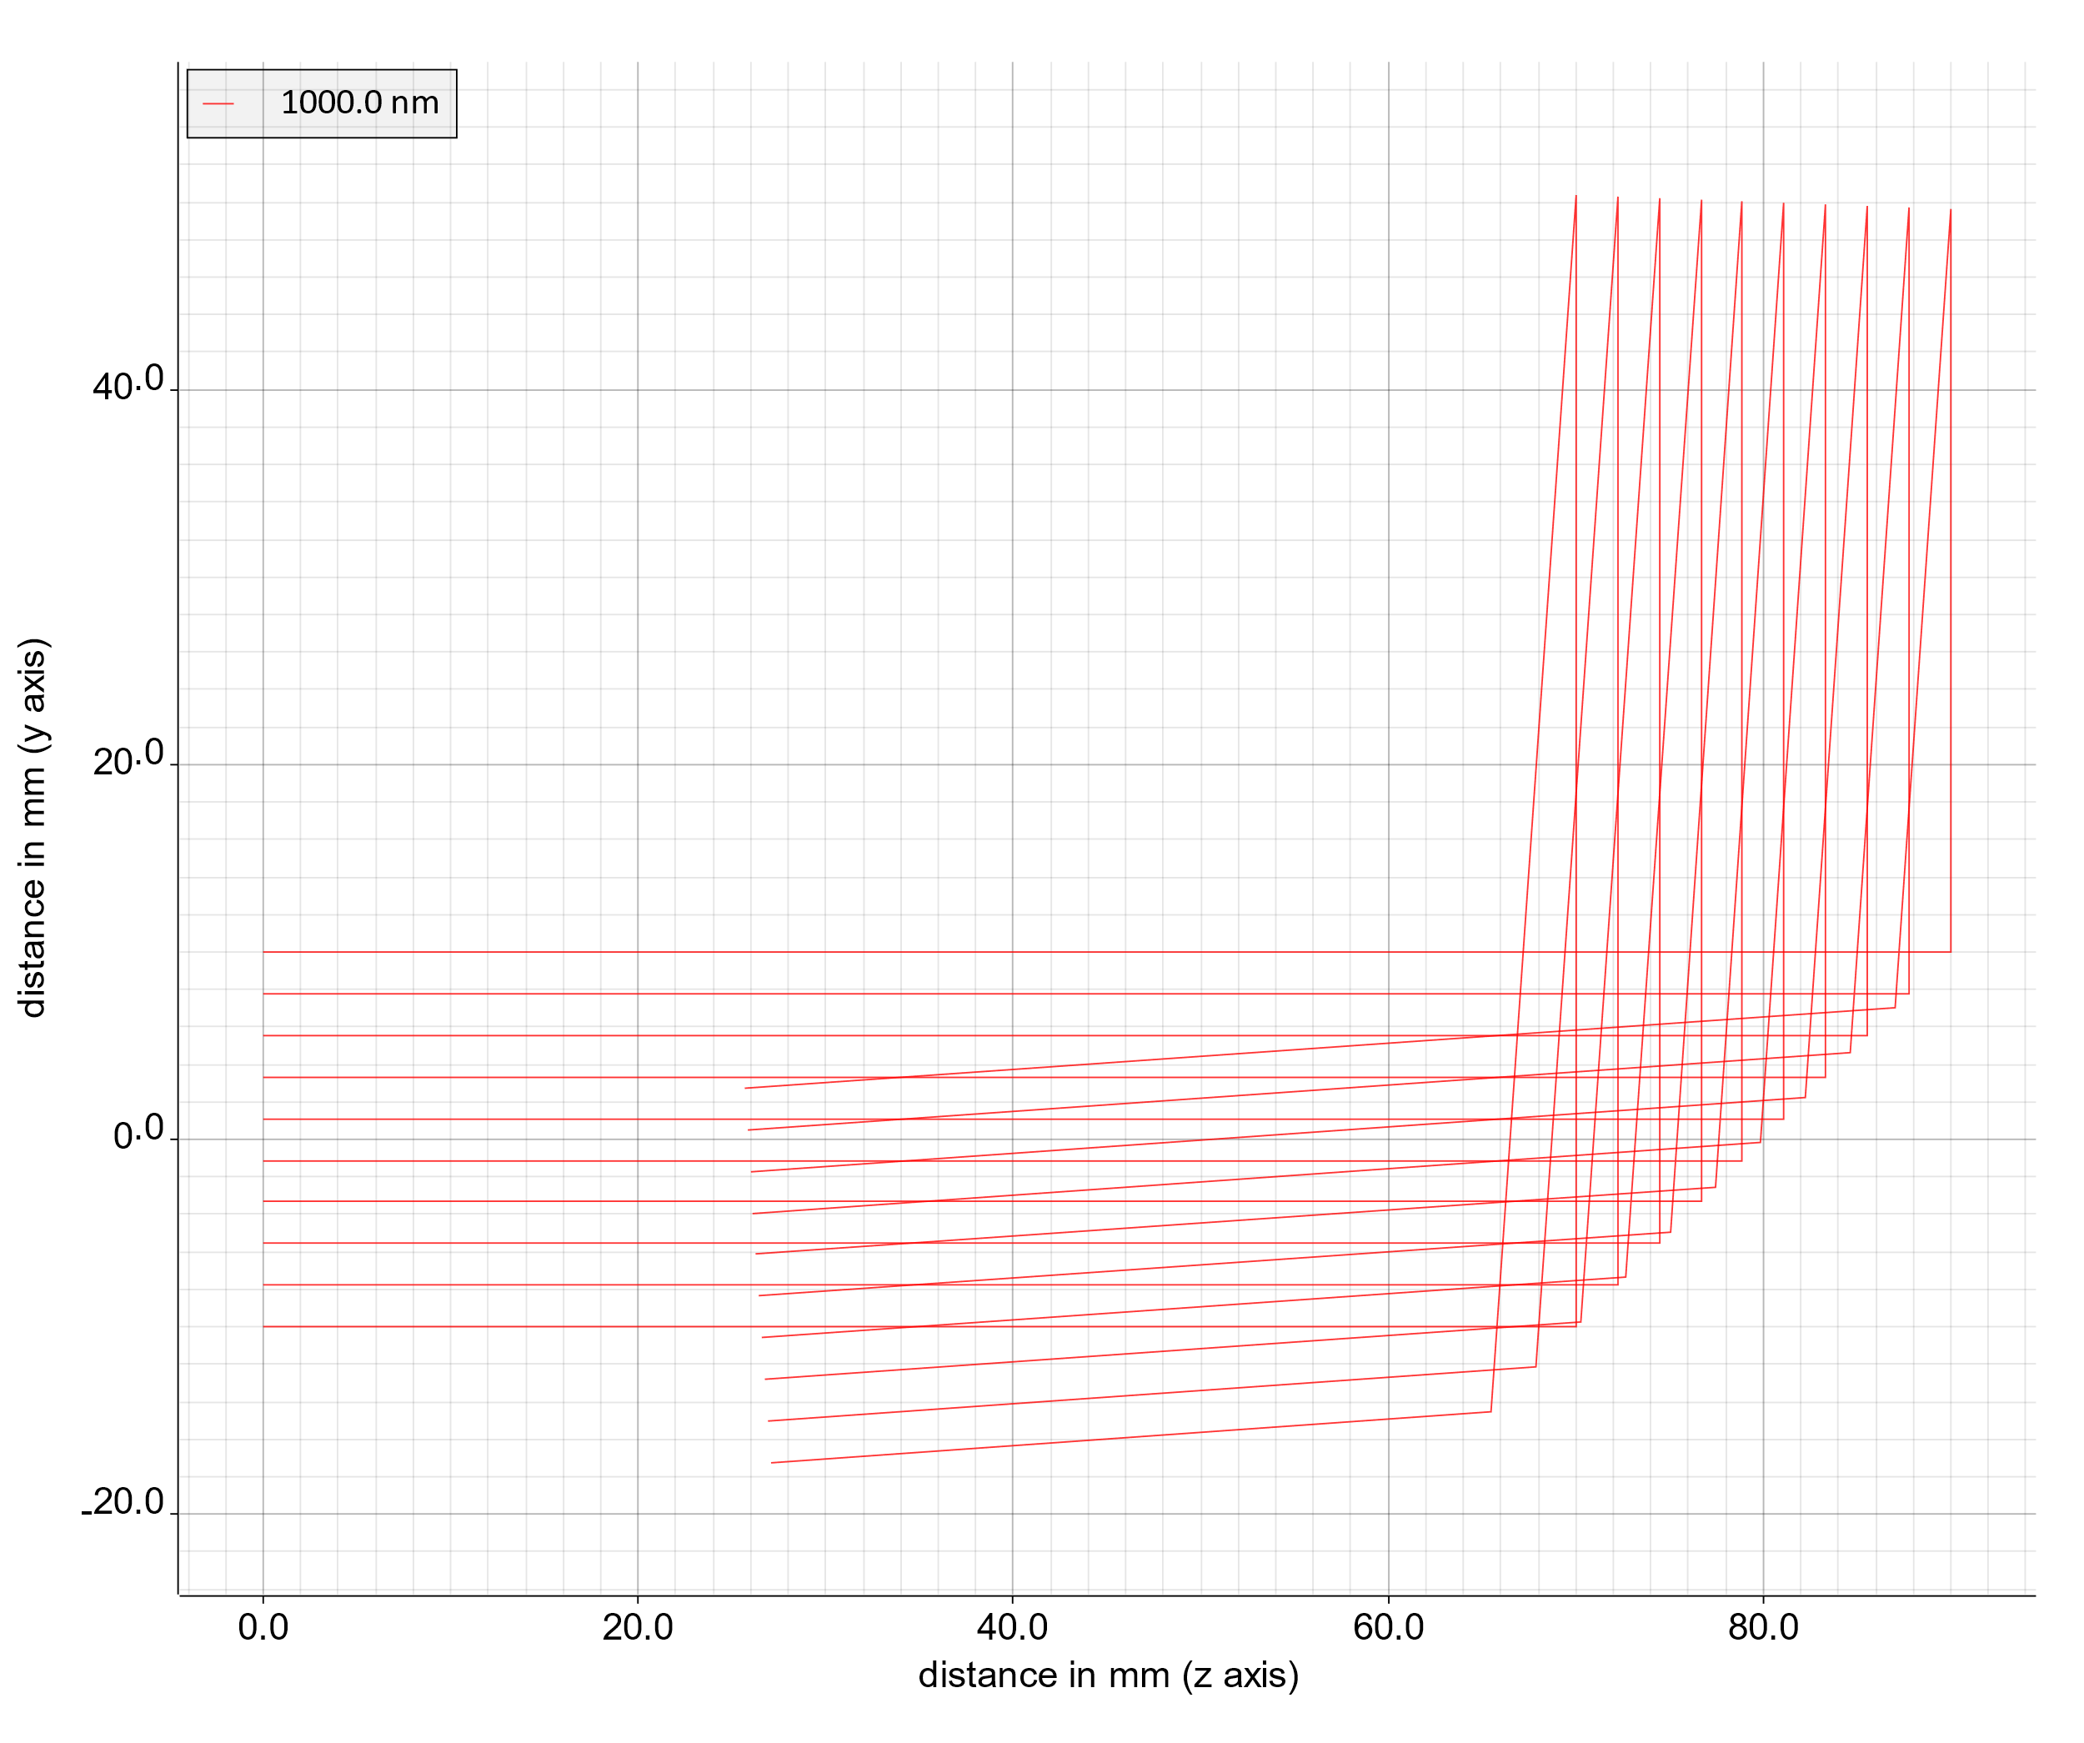

In the above example, we use two mirrors with the second one tilted by only 2 °, thus hitting the first mirror again.

# New optical elements

As shown above, the new release now includes flat and spherically curved mirrors. Furthermore, cylindric lenses have been added.

# Improved analysis reports

While the past releases generated analysis reports in PDF format, we decided to switch to HTML reports for several reasons: The used PDF library had many dependencies to other software packages which became more and more annoying to handle properly. In addition, the formatting possibilities of this library were rather limited. In particular, the correct handling of page breaks was almost impossible. The switch to a HTML report generation reduced the executable size by about 40 %.

The generated HTML report can be easily inspected using a simple web browser. In order to still generate a PDF document, almost all browsers offer the possibility to print the document to a PDF printer. There is still room for improvements and the layout / styling will become better in the next releases.

Link mit Beispiel Report

# Support for ambient medium

With this release a global ambient medium can be defined. By default, it is still defined as ‘vacuum’. However, it is now possible to define a new medium such as ‘air’ which is used for the propagation between the optical nodes.

# Improved warnings during analysis

Warnings and error messages have been significantly improved in this release. For example, if you want to model an energy meter of a given detector size you define a corresponding input aperture (such as a circular or a rectangular area). During analysis, a warning is issued now if incoming rays miss this surface indicating that the measured energy might not be “the full story”.

# Further improvements

Besides above highlights, a lot of development work went in bug fixing and smaller improvements as well as a heavily extended test suite. Some statistics:

* 42 tickets closed
* > 300 repository commits
* > 580 unit tests
* > 90 % code coverage by unit tests
* > 30.000 lines of code

For the upcoming release, we will concentrate on the development of a new module for the automatic calculation of ghost foci in complex optical systems.